Final Assignment Task2: Write a spring boot application to perform CRUD operations on Insurance domain. Looking at the real time application, you can decide the fields. Insert, Update, Delete and display all functionality data should reflect in the database table.

Controller

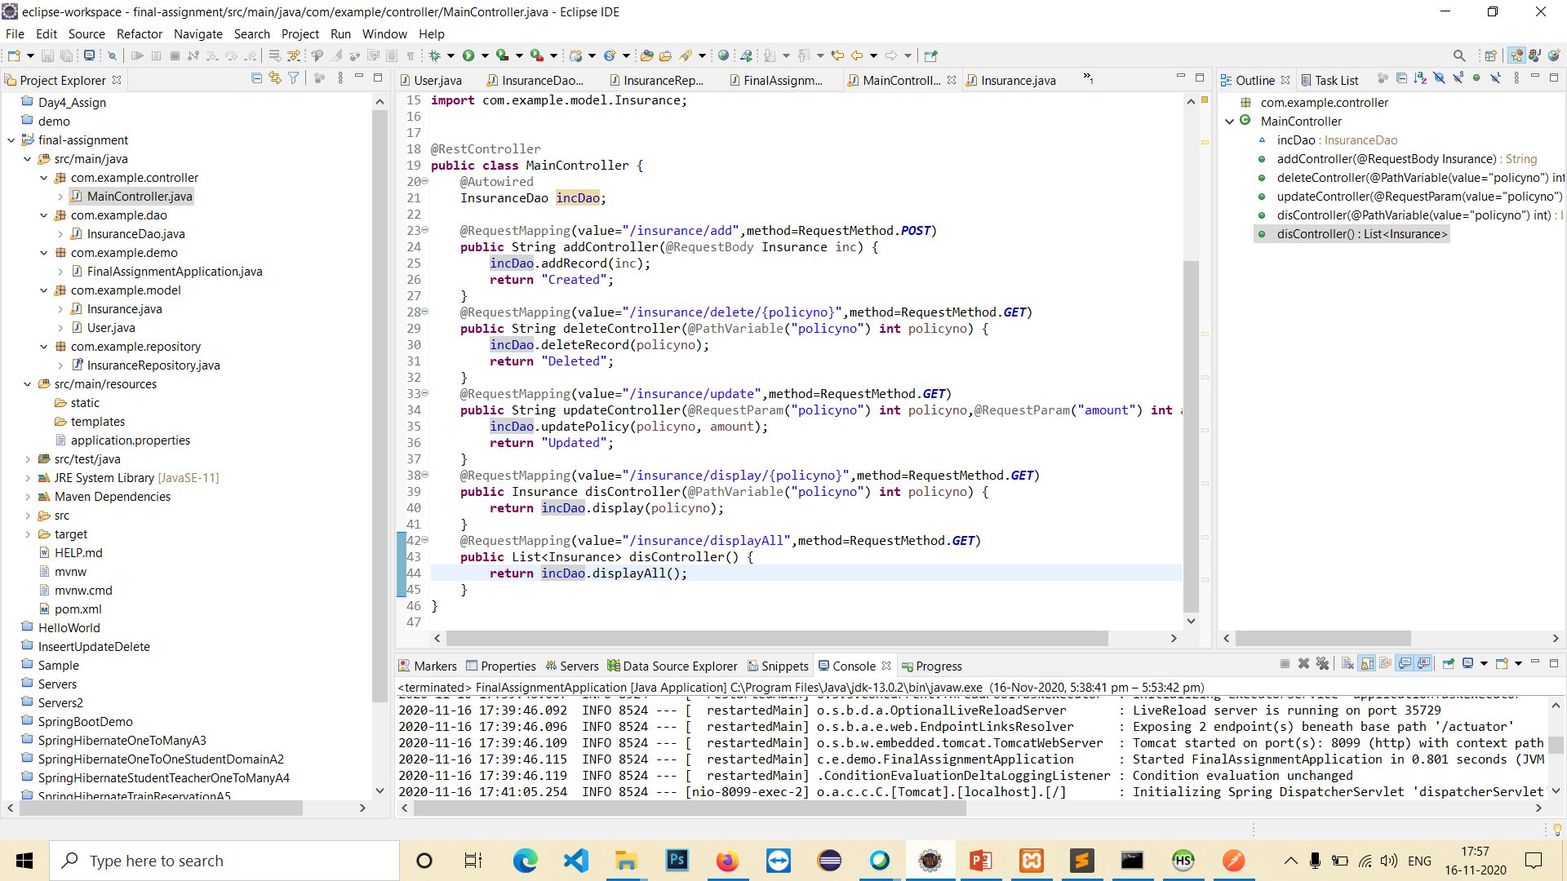

Insurance Dao Service

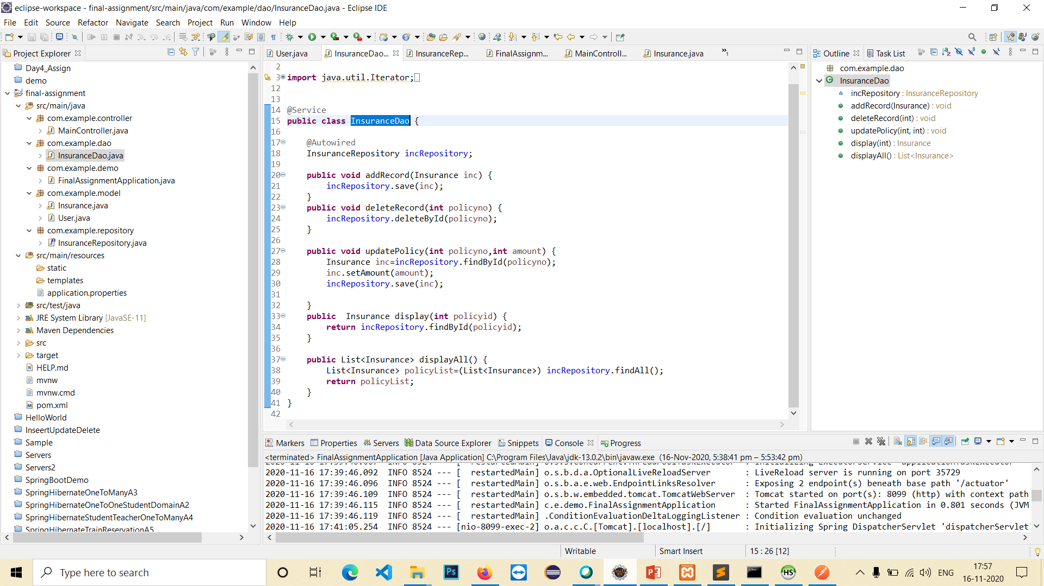

Insurance Class

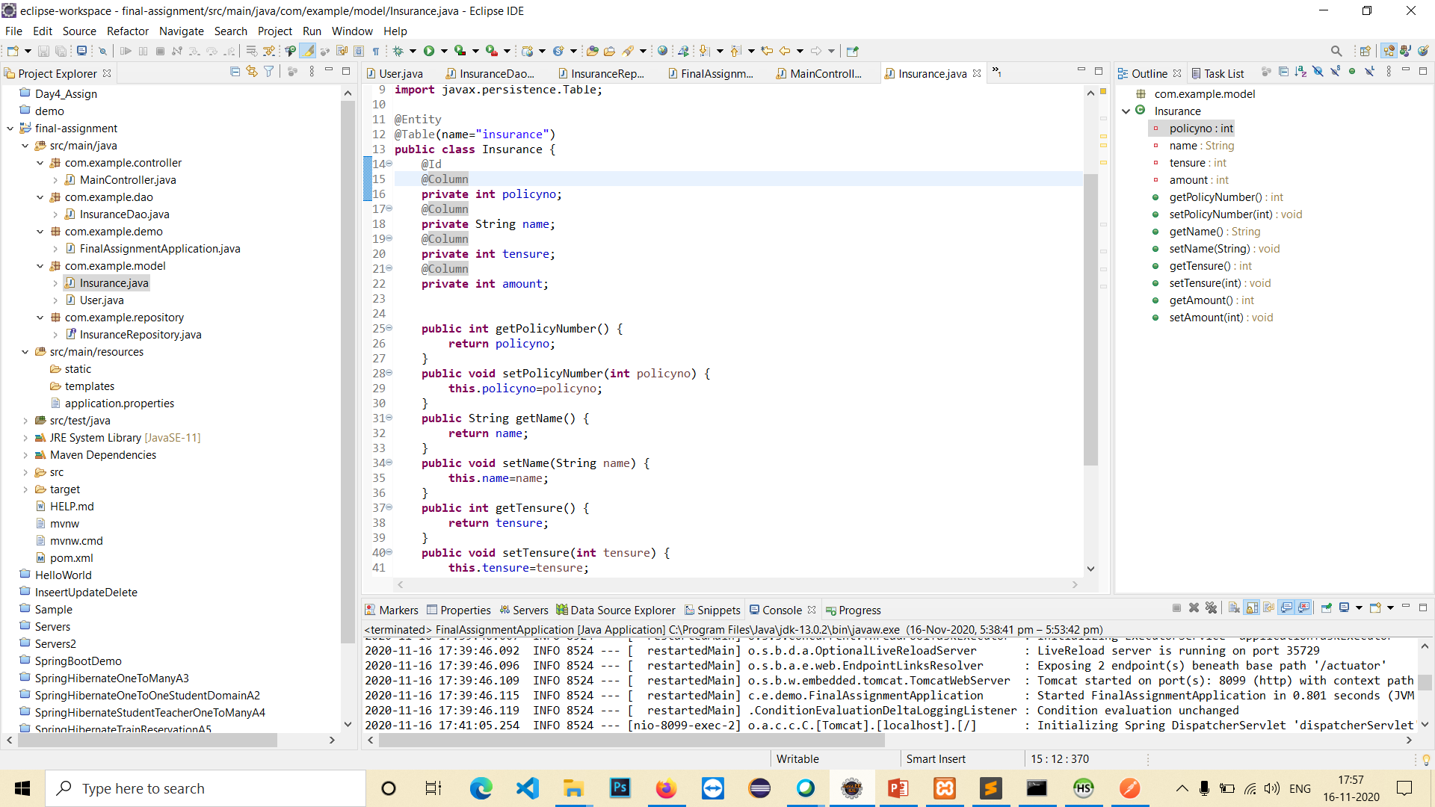

Insurance Repository

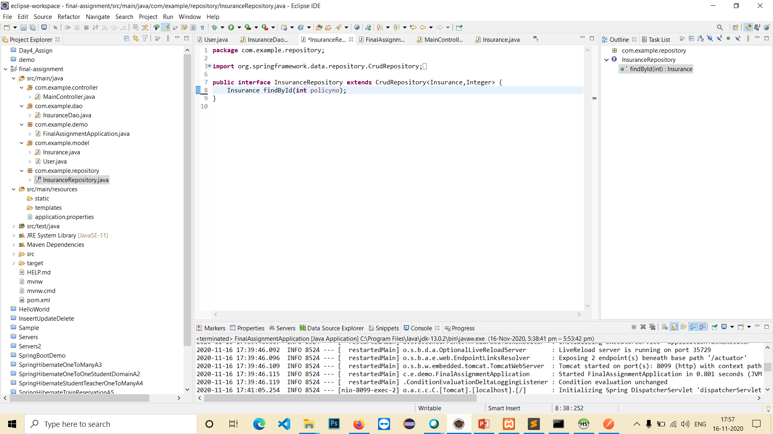

Results:

Create Policy: Sending Json Data using POST Method

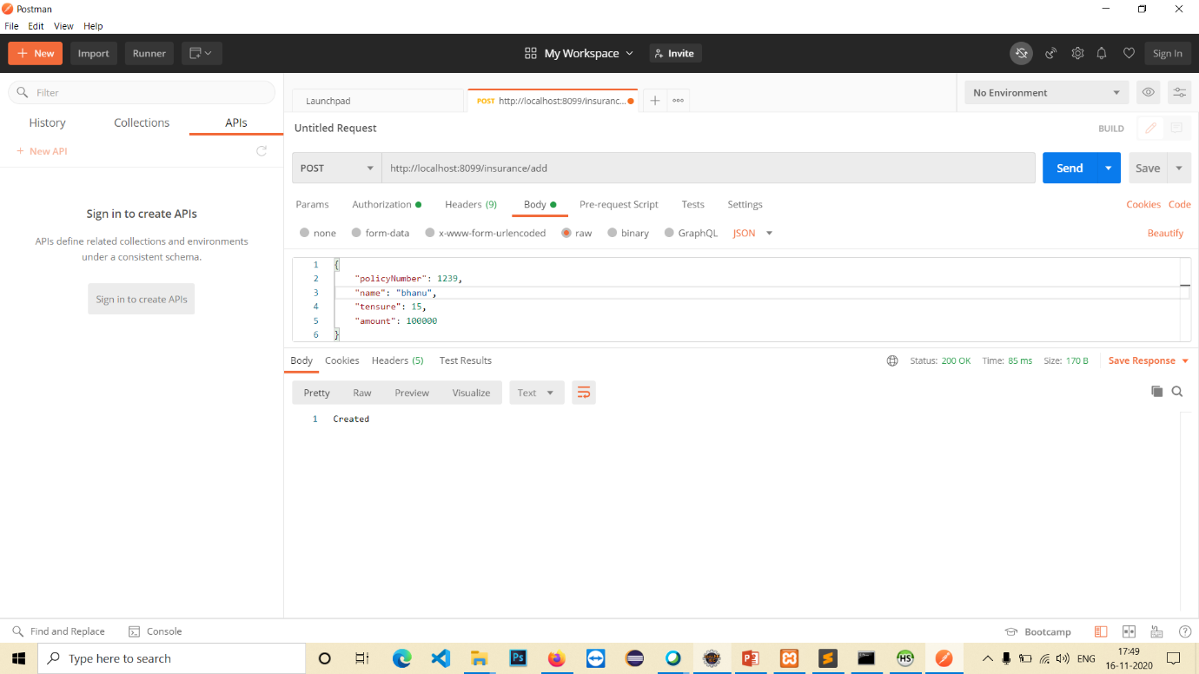

Displaying All Policies

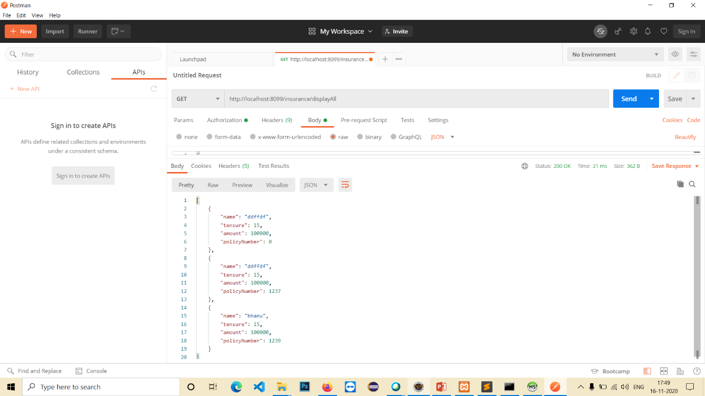

Displaying Single Policy: policy number send through URL

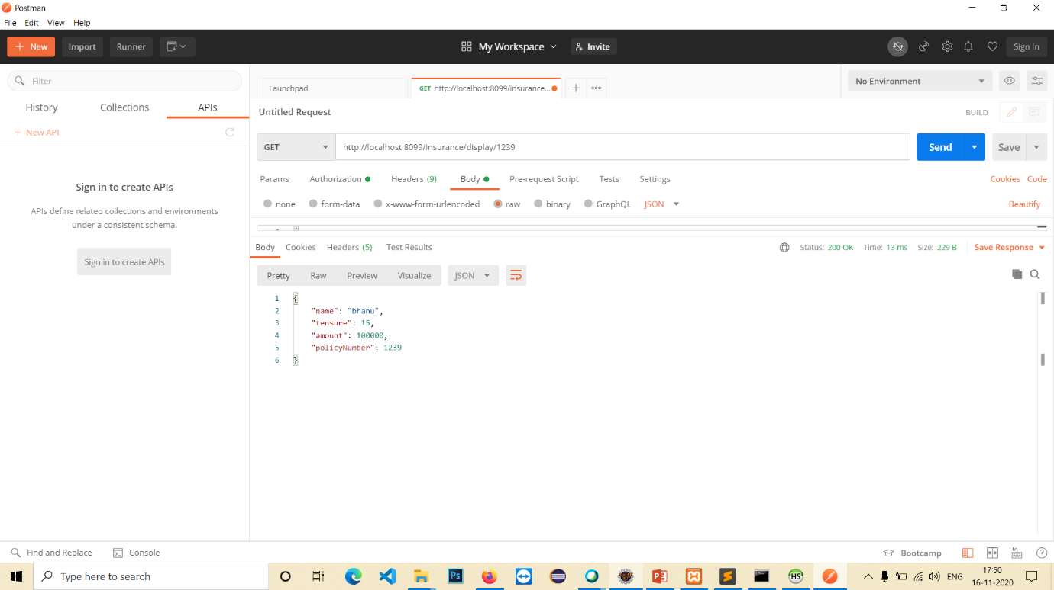

Delete Policy: policy number send through URL

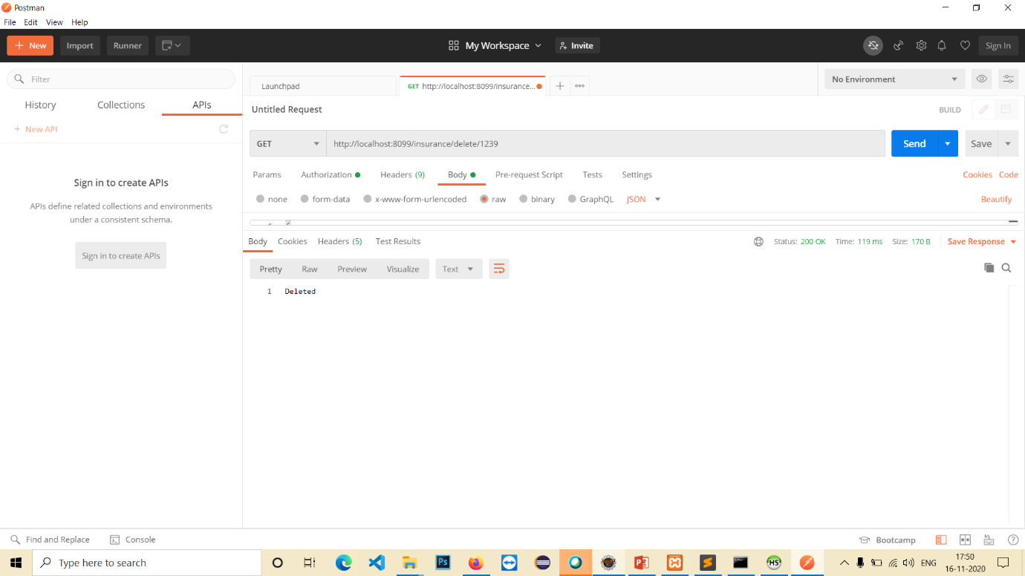

Display All after Delete:

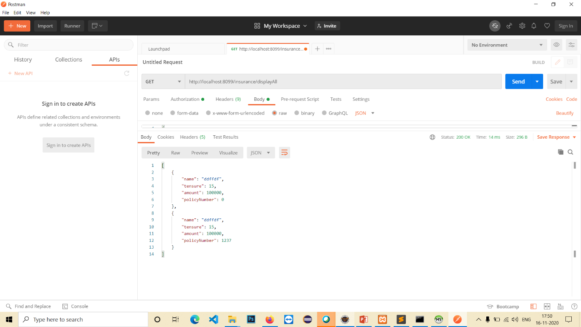

Update Policy:

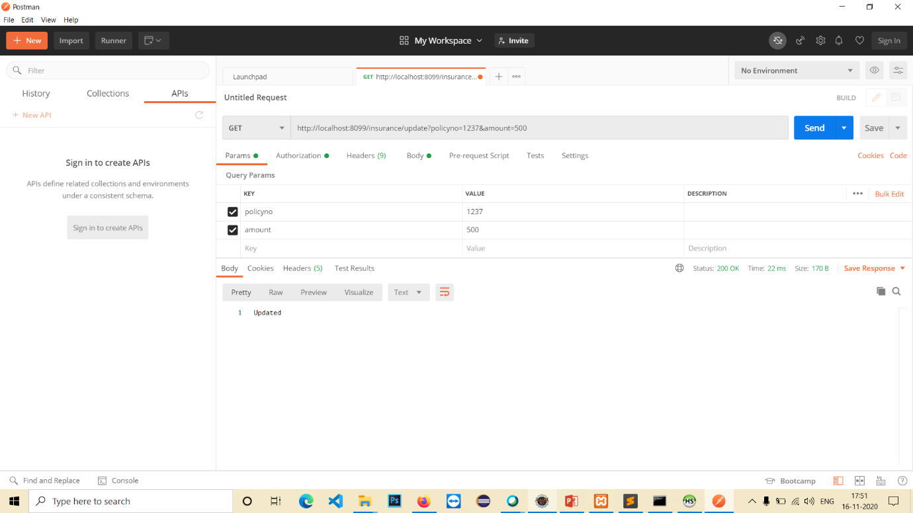

Results after Update:

